Matt Boler
ELEC7450 – Project 4

Despite being a common image enhancement technique, histogram equalization doesn’t always improve the quality of an image. For example, with the quarter picture, shown below, the background noise is amplified and the quarter itself is noticeably darker than it should be. Instead, an intensity adjustment, shown below, can have better results. The chosen adjustment represents a nonlinear dynamic range compression.

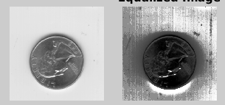
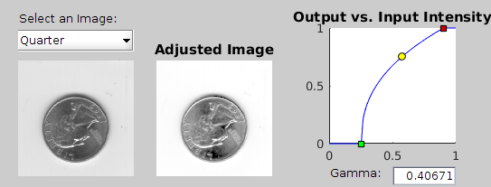
By generating a weighted average of an image and the same image convolved with an averaging filter, a smoothed image with the edges preserved can be generated. An example of this process is shown below, where the left is the original, the center is filtered, and the right is the difference between the two. Code to do this is attached at the end of this memo. When using filters of size 3x3, 5x5, and 7x7, increasing the filter size smooths the image more but reduces the edge quality. For a given filter size, increasing S increases the smoothing and reduces the edge quality. Unexpectedly, the smoother the image, the larger the SSD. The same follows for the SAD.
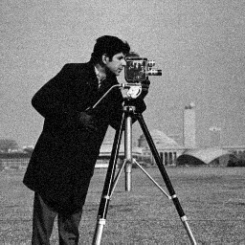
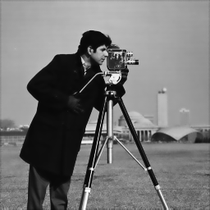

Given repeated copies of two images of a person, a good first step to identifying the person would be to average the corresponding frames to decrease the variance. Also, because the images are taken at close points in time it might be possible to identify a transform which maps one image to the other given a set of points identified near the face for accuracy. If this warp is successful, cropping the images to only the face and then averaging would give an even less noisy image.

function [ y ] = enhaceEdges( image, M, S )

ker_v = [1 2 1; 0 0 0; -1 -2 -1];
ker_h = ker_v';

sm = conv2(double(image), double(ker_v), 'same');
sn = conv2(double(image), double(ker_h), 'same');

grad_image = sqrt(sm.^2 + sn.^2);

filter = ones(M, M) ./ (M*M);
filtered_image = conv2(double(image), double(filter), 'same');
sa = conv2(double(grad_image), double(filter), 'same');

w = exp( -sa ./ S);

y = uint8((1 - w) .* double(image) + w .* double(filtered_image));

end

